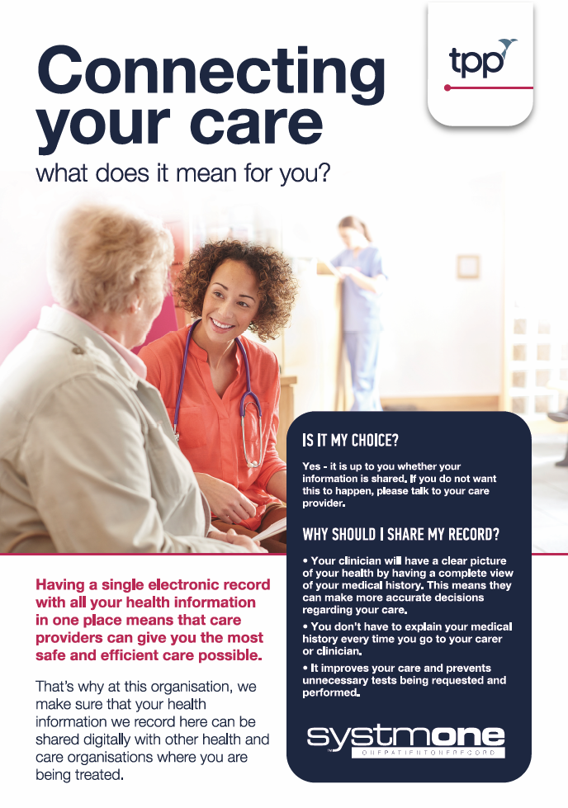

**Together4Healthcare Ltd**