Together4HealthcareLtd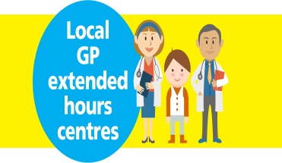
Together4Healthcare Ltd is a GP Led collaboration made up of following practices within your community, offering extended opening hours opening in evenings and weekends.
Linkway Medical Practice – The Lyng Centre, Frank Fisher Way , West Bromwich, West Midlands, B70 7AW
Dr R K Arora – The Lyng Centre, Frank Fisher Way , West Bromwich, West Midlands, B70 7AW
Hawes Lane Surgery – Rowley Healthcare, Hawes Lane , Rowley Regis, West Midlands, B65 9AF
New Street Surgery – New Street Hill Top , West Bromwich, West Midlands, B70 0HN
Bearwood Road Surgery – 348 Bearwood Road, Smethwick , Warley, West Midlands, B66 4ES
Dartmouth Medical Practice – 1 Richard Street , West Bromwich, West Midlands, B70 9JL
So what are the benefits for you ?
- Four centres across Sandwell – You will be offered a choice where to go and an appointment time which may be better for you. On weekends and after 18:30 on weekdays, you will be able to access appointments at one of the practices listed above.
- No Waiting in queues - You will be seen promptly and shouldn’t have to wait in a queue.
- Run by local GP’s and Nurses – The service will be operated by local GP’s and nurses from the Sandwell area, with access to your patient records.
On a day to day basis, from 08.00 – 18.30, you will see no change to the way your practice runs. Your own surgery will try to meet your needs first, but if you require an appointment urgently and they can’t fit you in or you prefer to see a clinician in the evening or weekend, you will be able to book at Four of the practices listed above.
Details of new opening hours and how to access the appointments from SEPTEMBER 2017 coming soon…..

